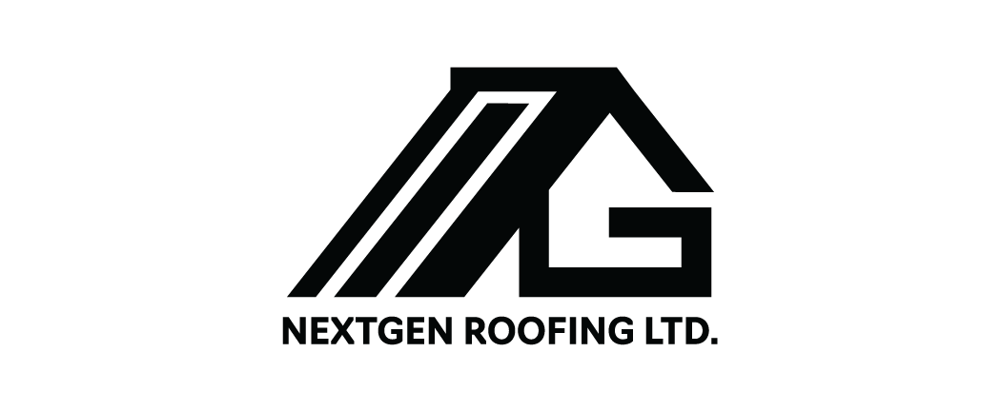
Address: 6922 sperling Avenue Burnaby v5e 2w2
Contact No : Cellphone (778) 302-1543 / Office (778) 834-0541
Email : nextgenroofing0822@gmail.com

TO :
JOB ADD:
CELL:

CONTRACT

PRODUCT: Malarkey Legacy (4 bundles per square)
With Materials, Bin and Labour

SCOPE OF WORK:

- Create a Site Protection Plan to protect the structures, driveway, garden, fences, decks, and stairs.
- Remove cedar shake roof system of the house/garage at the above address and deposit all debris into a garbage container.
- Install 3/8 plywood
- Install 30 pounder felt paper on all eaves and valleys
- Install malarkey synthetic (UDL)
- Install starter on all eaves and gay ball end
- Install 2x2 metal on all gay ball end
- Replace pluming/gooseneck/v ben
- Install 26 gauge w valley metal on all valley location
- Install Malarkey (Legacy) 4 bundle pr sq using hot dipped coil nail
- Install ridge vent on all ridge location
- Install (HP) EZ ridge cap on all hep/ridge
- Off/install (3) 2x4 Columbia skylight/ (1) 2x2 Columbia black in color

A C C E P T A N C E

This contract is approved and accepted. I (We) understand there are no oral agreements or understandings between the parties. The terms, provisions, plans (if any) and specifications in this contract is the entire agreement between the parties. Changes (if any) shall be done by written request of the interested party only and with the express approval of both contracting parties. Changes may incur additional cost depending upon the materials and labour involve on the part to be change.
All work caused by unforeseen events, natural calamities and similar occurrences beyond the control of man are not covered.

This project will carry a Transferrable 10-year workmanship/Material warranty on Labor from NextGen Roofing Ltd.

Approved and accepted by: _____________________ Signature:______________________
(Owner)
Telephone number: __ __ __ - __ __ __ - __ __ __ __ Date:_________________________

Approved and accepted by: ______________________ Signature:______________________
(Owner)
Telephone number: __ __ __ - __ __ __ - __ __ __ __ Date:_________________________

Approval (contractor):NEXTGEN ROOFING LTD_________________
Date: ________________________

Name: NOEMI SEBASTIAN_________________________________

SPECIAL INSTRUCTION:

ROOFING PROJECT:
All Labour and Materials:$43,700 +5% gst =$46,000 _____

Collection schedule Amount Payment to be made in installment as follows:

1. 50% upon delivery_____N/A_____________________

2. 50% at job completion___________N/A_______________

